Title：Optimization research based on Oracle database——

**Research on Optimization of query statement**

Name：王一同

Major：Software Engineering

ID：1552661

Phone：15301706703

Class Number：[42024403](http://4m3.tongji.edu.cn/eams/courseTableForStd!taskTable.action?lesson.id=111111112166467" \o "点击显示单个教学任务具体安排)

Date:2017/6/22

**Research on Optimization of query statement**

ABSTRACT

Oracle database is a relational database management system. It has been a leading position in the field of the database. Oracle database system is the world's popular relational database management system because of its good transportability, convenient operation and strong function.And it is suitable for all kinds of big, medium, small and micro computer environments.This paper based on Oracle database focuses on the query statement.The following will talk about the SQL query processing and then analyze the principles of different optimization. And it focuses on several ways to enhance the query statements of Oracle database, including my real project.

【Keywords】Oracle database, SQL statement, query operation, optimization

**Contents**

1 Introduction 1

2 Create and use indexes 2

2.1 Create necessary indexes 2

2.2 The principles of using index 3

3 Optimization of SQL statements 5

4 Rewrite the SQL statement 6

4.1 UNION ALL instead of UNION 6

4.2 WHERE instead of HAVING 6

5 Conclusion 8

[References](https://www.baidu.com/link?url=lMKnz3dPg6LQNjeVUbaZCVZQrI9epossjY6NmHX0-GIW35RgoF-97jkVIlPdh4fQUOWVT73vIww6Sre-aUkUwDeEZdUDLisyUQ0e2-THKN1ZmlAi_1LekyGfjAjU-cVv&wd=&eqid=90b80efd00372b960000000459494510" \t "https://www.baidu.com/_blank) 9

**1 Introduction**

The scope of this paper is limited to the optimization of query statement based on Oracle database. And several ways to enhance the query statements of Oracle database is the focus of this paper.

Database technology is the fastest growing and most widely used information technology in computer science and technology.As one of the techniques, database technology has expanded from many traditional commercial fields to many new ones areas such as medical, multimedia, economic, political, scientific, and other fields. And engineers try many ways to enhance the performance of database.Among them, the query operation of database is the most important, and the query efficiency becomes the key factor that affects the performance of Oracle database. So this paper will introduce some optimization of Oracle database query statement.

**2 Create and use indexes**

The index is a common and important database object in database. Creating index is an important way to optimize queries.Index is similar to the catalog of books. And process of index is equivalent of using the directory to quickly find the content of the desired article, which enables the query that acts on the table to perform more efficiently.

**2.1 Create necessary indexes**

The final criterion for determining the necessity of indexing is to determine whether these indexes are useful for our database's efficiency.The following will talk about some necessary processes of creating index based on my real project.

Firstly, we have to be familiar with our projects.We need to know which tables are used frequently, which tables often connect with other tables, which tables may have large amount of data. We must pay attention to these tables to meet the above conditions. Because indexes created on these tables will have a significant impact on the performance of SQL statements.

My real project, it’s a website offering travel services.For my project, the table of *user* is used frequently because the services of website are only provided for registered users.And the table of *user_info* often connects with other tables such as the table of *order, article* and so on. So I have to create index for the table of *user_info* to improve the efficiency of query statements.

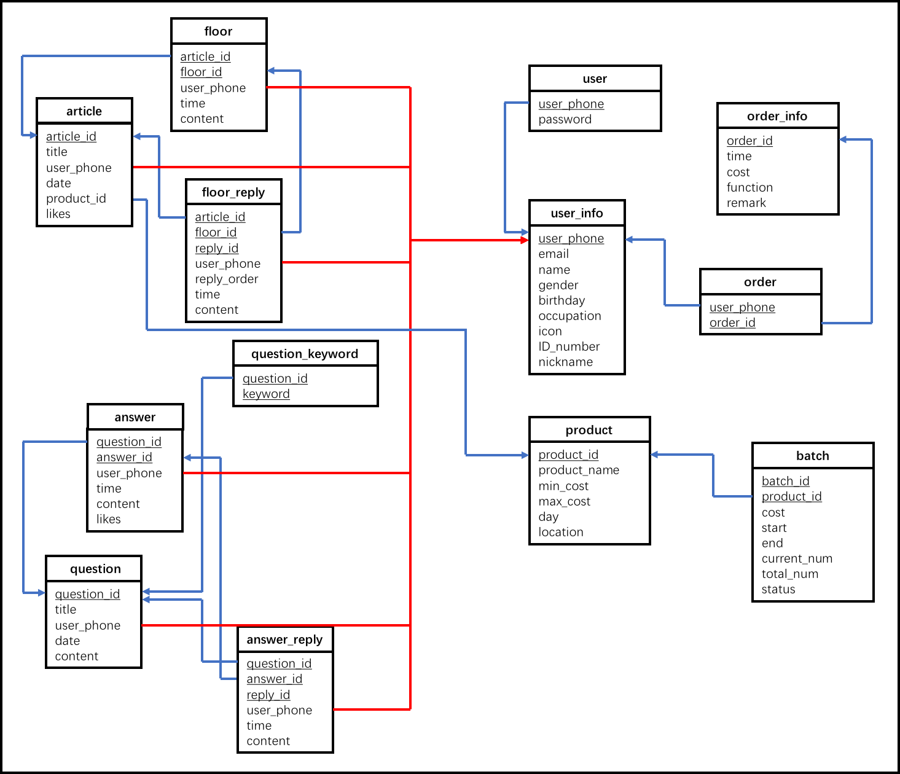

Figure 1.1 The tables of my real project “逆旅”

After the creation of the necessary index, it does not mean that the database performance improvement has been achieved satisfactory results. But it also needs to analysis some specific SQL statements: firstly, determine the index is actually been used. An index which is not working is a waste of resources. Second, determine whether the index is used reasonably.

**2.2 The principles of using index**

After creating necessary indexes, we have to maintain our indexes. If the table is updated, inserted, deleted and so on, the already created index needs to be updated. Therefore, the following principles need to be followed when using indexes:

(1) It is better to build indexes for columns that are queried by scope.

(2) If the table contains primary keys and foreign keys, it must be indexed.Taking the example of my real project, the primary key of *user* is *user_phone.*So I have to do this operation:

**create index** *user_phone_index* **on** *user(user_phone*);

(3) Do not create indexes for some special data types.Taking the example of my real project, I can’t create index for user’s birthday because of the type of this attribute is special.

(4) If you use too many operations such as insert and delete on the database, you can't build too many indexes.Taking the example of my real project, users can change their travel routes, so it’s unnecessary to create index for the table of *order.*

(5) The index can be integrated with the collection of where statements.

# 

**3 Optimization of SQL statements**

For database applications, optimization of SQL statements is an important factor in improving application efficiency. At first, I don’t pay attention to the optimization of SQL statements in my project and it slow down the loading of my application. So I will talk about some ways to improve application efficiency.

(1)Avoid execution of SQL statements without any conditions, because its query for large tables will be a long process. Taking the example of my real project, I did this operation to get the user’s information at first*:*

**Select** *name* **from** *user_info*;

This operation takes too much time and slow down my application. So I changed my code to find the same name in the table:

**Select** *name* **from** *user_info* **where** *name = “Kevin”*;

So the application becomes faster than former.

1. If you have constraints on the data in some tables, it is better to implement it with the SQL statements when you build the table, rather than implement it in the program. It means you have to certain the primary key, foreign key and so on when you build the table. Taking the example of my real project, we obey the BCNF and we certain the primary key and foreign key of every table.
2. Set a maximum value.The retrieval of large amounts of data takes long time, so set the pre-fetching of rows can improve the performance of the system.When the SQL statement returns the tuples more than maximum value, the database stops executing until the user issues a new command.

**4 Rewrite the SQL statement**

The following are some SQL statements to improve the efficiency of database.

**4.1 UNION ALL instead of UNION**

I knew that use **union all** in SQL statement will improve the efficiency of database from internet, so I tried it in my real project. I need to know two answers of the question about service, so I use this operation:

(**select** *content* **from** *answer* **where** *answer_id = “1”*)

**union all**

(**select** *content* **from** *answer* **where** *answer_id = “2”*)

And I compare this operation with use *union* and find that *union all* will improve the efficiency of query execution on the Oracle database. Because when we use the *union*, the two results will be merged by the Oracle database in *union all,* then it will be sorted and output. If we use *union all,* we don't need that sort of sorting.

**4.2 WHERE instead of HAVING**

Try not to use the *having* clause, because *having* will filter the result sets after retrieving all the result sets that satisfy the condition. The entire process requires sorting, count and a series of operations. But the *where* clause limits the number of records and reduces the amount of resources consumed in this aspect.

Taking my real project as the example, I do this operation to select male users:

**select** *name* **from** *user_info* **having** *gender = “男”*;

This operation will collect all tuples of user_info, and then give the names of male users. So I change this operation to the following:

**select** *name* **from** *user_info* **where** *gender = “男”;*

This operation give the names of male users before collecting all tuples of user_info, so it can improve the efficiency.

**5 Conclusion**

In addition to the above some optimization of Oracle database query statement, there are other ways to improve the efficiency of query statements such as creating bitmap index, sharing SQL statement and so on. For the Oracle database system, the key lies in the efficiency of query statements, especially the large database system. By analyzing the process of query statements in Oracle database, according to my real project, this paper points out several effective methods for Oracle database query optimization, and improves the performance of database.

**References**

[1] 周锦 . 基于 Oracle 数据库 SQL 语句优化规则的研究

北方工业大学 ,2013.

[2] 邹俊. 基于Oracle数据库系统性能调整与优化研究

江西财经大学 ,2016

[ 3] 吉斌武, 黄锐.分布式数据库中的查询优化[ J] .桂林航

天工业高等专科学校学报, 2006(3):29-31.

[4] 李凤云, 王守强.基于分布式数据库的SQL 语句性能优化

电脑知识与技术, 2005, 15:3-4.

[5] 胡欣杰.Oracle9I 数据库管理员指南

北京:北京希望电子出版社, 2002.

[6] [美] RobertGFreeman.OracleDBA必备技能详解

北京:清华大学出版社, 2006

[7][美] RichardJNiemiec.Oracle9i性能调整

北京:清华大学出版社, 2004.